**WEB DESIGNING PROJECT**

**CIA-II**

**SEM-III**

Group of 2-

Chris –165015

Siddhant- 165031

**About the Project:**

**Introduction:**

As part of our curriculum, we have been given a project for the CIA-II examinations. The subject is Web Designing and our project was to create a working responsive website that included the major web languages used to create real world websites. We had to create a website for any department of our choice in the college. For our project, we chose the Department of History.

**The Idea:**

For our website, we had reviewed various different possibilities, and designs that we would work on. We also drew physical sketches of the designs on paper to get an idea to get going. We finally agreed upon a minimalistic design approach that would fulfil all the criterions required for the project.

**Technologies used:**

HTML, CSS, JavaScript and jQuery.

**What we did:**

We have made a home page that has links to three other pages namely Events, Quiz and Info. The home page also has a slideshow of images we made using jQuery. It has an About us and Notices <div> attribute. The page ends with a footer, whose information we tried to keep as professional as possible.

The Event page has the information about the upcoming exhibition organised by the department, which asks to follow a link which if a user wishes register for the exhibition. The link takes us to a page where users are asked their basic contact information and in the end on clicking the register button, users are taken to a confirmation page where they can proceed to either home page or the events page.

The Quiz page has a quiz of a few history related questions that are evaluated using JavaScript.

The Info page is a basic HTML page, which has information regarding the faculty of the department.

We created an External CSS, which we used in the entire project using <link> tag. This was done to ensure uniformity among all the pages. However, we have also used inline and embedded CSS where we deemed it was necessary to change a particular style.

The footer of the page, which was mentioned earlier in the paragraphs, is also used in every other page to make it look professional.

**Index:**

|  |  |
| --- | --- |
| Topics | Page No. |
| Cover | 1 |
| About | 2 |
| Index | 3 |
| Codes | 4 |
| Home | 4 |
| Events | 7 |
| Form | 8 |
| Confirmation | 9 |
| Quiz | 10 |
| Info | 12 |
| CSS | 13 |
| Snaps | 17 |
| Software Used | 18 |
| Experience | 18 |
| Bibliography | 18 |

**Codes:**

HOME PAGE:

<!doctype HTML>

<html>

<head>

<meta content="text/html"; charset="utf-8">

<link rel="stylesheet" type="text/css" href="Newstyle.css">

<script src="jquery.js"></script>

<!-------------Slide show logic--------------->

<script>

$(function(){

var slides= $('.slideShow>li');

var slideCount=0;

var totalSlides= slides.length;

var slideCache=[];

(function preloader(){

if(slideCount < totalSlides){

//load images

slideCache[slideCount]= new Image();

slideCache[slideCount].src= slides.eq(slideCount).find('img').attr('src');

slideCache[slideCount].onload= function(){

slideCount++;

preloader();

}

} else{

//run the show

slideCount=0;

SlideShow();

}

}());

function SlideShow(){

//code here

slides.eq(slideCount).fadeIn(1000).delay(3000).fadeOut(1000, function(){

slideCount< totalSlides- 1 ? slideCount++ : slideCount= 0;

SlideShow();

});

}

});

</script>

<!--Styling the anchor tag-->

<style>

a:link{

color:#00C;

text-decoration:blink;

}

a:visited{

color:#00C;

text-decoration:none;

}

a:hover{

color:#F00;

text-decoration:underline;

}

</style>

<title>HOME||SXDH</title>

</head>

<body>

<!--container-->

<div id="container">

<!--header-->

<div id="header">

<div id="logo"></div>

<div id="info"><h1>St. Xavier's College, Mumbai(Autonomous)</h1>

<h1 style="font-family:Macondo Swash Caps; font-size:36px">Department Of History</h1></div>

<div id="navbar">

<ul>

<li><a href="event.html" target="_self">Events</a></li>

<li><a href="Quiz.html" target="_self">Quiz</a></li>

<li><a href="info.html" target="_self">Info</a></li>

</ul>

</div>

</div>

<!--content-->

<div id="content">

<div id="banner">

<div id="slideShowContainer">

<ul class="slideShow">

<li><img src="10.jpeg"/></li>

<li><img src="11.jpeg"/></li>

<li><img src="14.jpeg"/></li>

</ul>

</div>

</div>

<div id="left" style="font-family:Annie Use Your Telescope">

<h1 style="text-align:center;text-decoration:underline">ABOUT US</h1>

<p style="text-align:center; font-size:32.99px">

We are a young and dynamic department. The crowd is small and the faculty is young too.You can say we are a small family in Xaviers. That said, we have some pretty great debates in the class that would blow your minds away. Anybody’s welcome to visit our class to observe this. We also visit those exotic historic locations as a part of our curriculum, an added advantage.

</p>

</div>

<div id="right" style="font-family:Marcellus SC">

<h1 style="text-align:center; text-decoration:underline">NOTICES</h1>

<ul style="text-align:center; font-size:37.50px">

<li>Stay tuned for more info about the documentries</li>

<li>Check out facebook group</li>

<li>Click on the EVENTS link for info about the upcoming events!!</li>

<li>More field trips to be organised next semester</li>

</ul>

</div>

</div>

<!--footer-->

<div id="footer" style="font-family:Arial, Helvetica, sans-serif; text-align:center">

<h5>Department of History, St. Xaviers College &copy;</h5>

<h5>Designed by BscIT||2017 &copy;</h5>

</div>

</div>

</body>

</html>

EVENTS:

<!doctype html>

<html>

<head>

<link rel="stylesheet" type="text/css" href="Newstyle.css">

<style>

a:link{ color:#FFF}

a:visited{ color:#FFF}

a:hover{ color:#F00}

</style>

<title>Events||SXDH</title>

</head>

<body>

<!--container-->

<div id="container">

<!--header-->

<div id="header">

<div id="logo"></div>

<div id="info"><h1>St. Xavier's College, Mumbai(Autonomous)</h1>

<h1 style="font-family:Macondo Swash Caps; font-size:36px">Department Of History</h1>

</div>

<!--Content-->

<div id="content">

<div id="banner" style="background:#669; height:auto">

<h1 style="text-align:center">Are you interested in stamps?</h1>

<p style="font-size:24px"> Does the history of stamps often intrigue you?<br>

Stamp enthusiasts, come, register for the biggest stamp exhibition at St.Xaviers College.<br>

Welcome to Deutsche डाक.<br>

<img src="3.jpg">&nbsp;&nbsp;&nbsp;&nbsp;&nbsp;&nbsp;&nbsp;&nbsp;&nbsp;&nbsp;<img src="4.jpg">

<h1 style="text-align:center">Registrations Open Now!!</h1><br>

<h3 style="font-size:25px"><a href="form.html">Click Here to register</a></h3>

</p>

</div>

</div>

<!--footer-->

<div id="footer" style="font-family:Arial, Helvetica, sans-serif">

<h5>Department of History, St. Xaviers College &copy;</h5>

<h5>Designed by BscIT||2017 &copy;</h5>

</div>

</div>

</body>

</html>

FORM:

<!doctype html>

<html>

<head>

<link rel="stylesheet" type="text/css" href="Newstyle.css">

<title>FORM||SXDH</title>

</head>

<body>

<div id="container">

<div id="header">

<div id="logo"></div>

<div id="info"><h1>St. Xavier's College, Mumbai(Autonomous)</h1>

<h1 style="font-family:Macondo Swash Caps; font-size:36px">Department Of History</h1></div>

<div id="content">

<div id="banner" style="background:#690; color:#FFF">

<h1 style="text-align:center">Registration</h1>

<form id="f2">

<h3>Name: <input type="text" name="name" id="name"></h3><br>

<h3>Phone: <input type="text" name="phn" id="phn"></h3><br>

<h3>Email: <input type="text" name="email" id="email"></h3><br>

<h3>UIDNo.: <input type="text" name="uid" id="uid"></h3><br>

<input type="button" id="b1" value="Register" onClick="location.href='regcon.html'">

</form>

</div>

</div>

<!--footer-->

<div id="footer" style="font-family:Arial, Helvetica, sans-serif">

<h5>Department of History, St. Xaviers College &copy;</h5>

<h5>Designed by BscIT||2017 &copy;</h5>

</div>

</div>

</body>

</html>

CONFIRMATION:

<!doctype html>

<html>

<head>

<link rel="stylesheet" type="text/css" href="Newstyle.css">

<title>Confirmation||SXDH</title>

</head>

<body>

<div id="container">

<!--header-->

<div id="header">

<div id="logo"></div>

<div id="info"><h1>St. Xavier's College, Mumbai(Autonomous)</h1>

<h1 style="font-family:Macondo Swash Caps; font-size:36px">Department Of History</h1>

</div>

<div id="banner" style="background:#330">

<form>

<h2 style="text-decoration:underline; font-size:32px">Registration Succesful!</h2><br>

<h3>Click for Homepage <input type="button" id="home" value="Home" onClick="location.href='Newhome.html'"></h3><br>

<h3>Click for Event page <input type="button" id="event" value="Event" onClick="location.href='event.html'"></h3>

</form>

</div>

<!--footer-->

<div id="footer" style="font-family:Arial, Helvetica, sans-serif">

<h5>Department of History, St. Xaviers College &copy;</h5>

<h5>Designed by BscIT||2017 &copy;</h5>

</div>

</div>

</body>

</html>

QUIZ:

<!DOCTYPE HTML>

<html>

<head>

<meta content="text/html"; charset="utf-8">

<link rel="stylesheet" type="text/css" href="Newstyle.css">

<script>

var sum=0;

function fn_play(){

document.getElementById("que").style.display='block';

}

function fn_quiz(){

var ans;

ans=document.querySelector('input[name="q1"]:checked').value;

if (ans=="Egypt"){

sum=sum+2;}

else{

sum=sum-1;}

ans=document.querySelector('input[name="q2"]:checked').value;

if (ans=="776_BC"){

sum=sum+2;}

else{

sum=sum-1;}

ans=document.querySelector('input[name="q3"]:checked').value;

if (ans=="1498"){

sum=sum+2;}

else{

sum=sum-1;}

ans=document.querySelector('input[name="q4"]:checked').value;

if (ans=="1215"){

sum=sum+2;}

else{

sum=sum-1; }

alert("Your Score is" +sum);

/*document.getElementById("myform").reset(); */

document.getElementById("xform").reset();

}

</script>

<title>QUIZ||SXDH</title>

</head>

<body>

<div id="container">

<!--header-->

<div id="header">

<div id="logo"></div>

<div id="info"><h1>St. Xavier's College, Mumbai(Autonomous)</h1>

<h1 style="font-family:Macondo Swash Caps; font-size:36px">Department Of History</h1>

</div>

</div></div>

<div id="form1">

<form id="myform">

<h3>&nbsp;&nbsp;&nbsp;&nbsp;NAME:&nbsp;&nbsp;&nbsp;<INPUT type="text" id="txt_name" placeholder="Enter Name"></h3>

<h3>&nbsp;&nbsp;&nbsp;&nbsp;AGE:&nbsp;&nbsp;&nbsp;&nbsp;&nbsp;&nbsp;&nbsp;<INPUT type="text" id="txt_age" placeholder="Enter Age"></h3>

<h3>&nbsp;&nbsp;&nbsp;&nbsp;E-MAIL:<INPUT type="text" id="txt_email" placeholder="Enter E-Mail id"> </h3>

<p><h3>&nbsp;&nbsp;&nbsp;&nbsp;UID No.:&nbsp;<INPUT type="text" id="txt_email" placeholder="Enter UID number"></p></h3><br><br><br>

<br><button type="button" onClick="fn_play()" id="btn_1">Play Quiz</button>

</form></div>

<div id="que" style="background:#FF9; color:#300; display:none">

<form id="xform">

<h2 style="text-align:center"><p>Welcome to the Quiz!!</p><h2>

<h3><i>Select any one answer from the choices</i></h3>

<h4>1.Which of the following is called 'Gift of Nile'?<br>

<INPUT type="radio" name="q1" value="India" id="Q_1">India<br>

<INPUT type="radio" name="q1" value="China" id="Q_1">China<br>

<INPUT type="radio" name="q1" value="Egypt" id="Q_1">Egypt<br>

<INPUT type="radio" name="q1" value="Nigeria" id="Q_1">Nigeria<br>

2.When were the first olympics held?<br>

<INPUT type="radio" name="q2" value="776_BC" id="Q_2">776 BC<br>

<INPUT type="radio" name="q2" value="780_BC" id="Q_2">780 BC<br>

<INPUT type="radio" name="q2" value="540_BC" id="Q_2">540 BC<br>

<INPUT type="radio" name="q2" value="600_BC" id="Q_2">600 BC<br>

3.Vasco da Gama reached India in the year?<br>

<INPUT type="radio" name="q3" value="1495" id="Q_3">1495<br>

<INPUT type="radio" name="q3" value="1488" id="Q_3">1488<br>

<INPUT type="radio" name="q3" value="1489" id="Q_3">1489<br>

<INPUT type="radio" name="q3" value="1498" id="Q_3">1498<br>

4.Magna Carta was signed in the year?<br>

<INPUT type="radio" name="q4" value="1210" id="Q_4">1210<br>

<INPUT type="radio" name="q4" value="1220" id="Q_4">1220<br>

<INPUT type="radio" name="q4" value="1215" id="Q_4">1215<br>

<INPUT type="radio" name="q4" value="1225" id="Q_4">1225<br></h4>

<button type="button" onClick="fn_quiz()">Submit</button></div>

</form>

<!--footer-->

<div id="footer" style="font-family:Arial, Helvetica, sans-serif; text-align:center">

<h5>Department of History, St. Xaviers College &copy;</h5>

<h5>Designed by BscIT||2017 &copy;</h5>

</div>

</body>

</html>

INFO:

<!doctype html>

<html>

<head>

<link rel="stylesheet" type="text/css" href="Newstyle.css">

<title>General Info||SXDH</title>

</head>

<body>

<!--container-->

<div id="container">

<!--header-->

<div id="header">

<div id="logo"></div>

<div id="info"><h1>St. Xavier's College, Mumbai(Autonomous)</h1>

<h1 style="font-family:Macondo Swash Caps; font-size:36px">Department Of History</h1>

</div>

<div id="content">

<div id="banner" style="background:#CCC; color:#003">

<h1 style="text-align:center; text-decoration:underline; color:#000">Faculty</h1>

<h2 style="text-align:justify">Dr. Baptist A. Menezes, M.A., Ph.D. &nbsp;&nbsp;&nbsp;Principal and Head of Department(acting)<br>

Mr. Avkash D. Jadhav, M.A.&nbsp;&nbsp;&nbsp;Assoc. Prof. (On FIP Leave)<br>

Ms. Kaizeen Jehangir, M.A.&nbsp;&nbsp;&nbsp;Asst. Prof. (On Leave Vacancy)

</h2>

</div>

</div>

<!--footer-->

<div id="footer" style="font-family:Arial, Helvetica, sans-serif;">

<h5>Department of History, St. Xaviers College &copy;</h5>

<h5>Designed by BscIT||2017 &copy;</h5>

</div>

</div>

</body>

</html>

External CSS :

@import url('https://fonts.googleapis.com/css?family=Marcellus SC');

@import url('https://fonts.googleapis.com/css?family=Macondo Swash Caps');

@import url('https://fonts.googleapis.com/css?family=Annie Use Your Telescope');

@import url('https://fonts.googleapis.com/css?family=Baumans');

html , body{

background-image:url(1.jpg);

margin:auto;

}

#container{

width:100%;

height:100%;

margin:0, auto;

}

#header{

width:100%;

height:20%;

border-bottom:1px solid #630; background:#630;

text-align:center;

font-family:Marcellus SC;

/*text-decoration:underline;*/

font-size:16px;

color:#FFF;

}

#logo{

float:left;

width:95px;

height:95px;

margin:10px;

background-image:url(logo1.png);

}

#navbar{

height:25%;

clear:both;

}

#navbar ul{

margin:0;

padding:0;

list-style-type:none;

}

#navbar ul li{

padding:5px;

float:left;

}

#navbar ul li a{

font-size:28px;

/*float:left;*/

padding:0 0 0 300px;

display:block;

}

#banner{

background:inherit;

height:500px;

clear:both;

}

#slideShowContainer{

position:inherit;

width:700px;

height:481px;

top:0px;

left:0px;

right:0px;

bottom:0px;

margin:auto;

border:1px solid #000;

box-shadow:0px 1px 20px #000;

border-radius:5px;

overflow:hidden;

/*clear:both;*/

}

.slideShow{

position:absolute;

margin:0px;

padding:0px;

list-style:none;

}

.slideShow>li{

position:absolute;

top:0px;

left:0px;

display:none;

}

#left{

float:left;

width:600px;

height:auto;

padding:20px;

background:#300;

border:8px solid #300;

color:#FFF;

}

#right{

float:right;

width:600px;

height:auto;

padding:20px;

background:#300;

border:8px solid #300;

color:#FFF;

}

#footer{

background:#000;

height:80px;

clear:both;

color:#FFF;

}

/*for the quiz page*/

#form1{

background-color:#903;

color:#FF0;

border-bottom:1px solid #630;

background:#630;

font-size:20px;

}

#f2{

text-decoration:none;

}

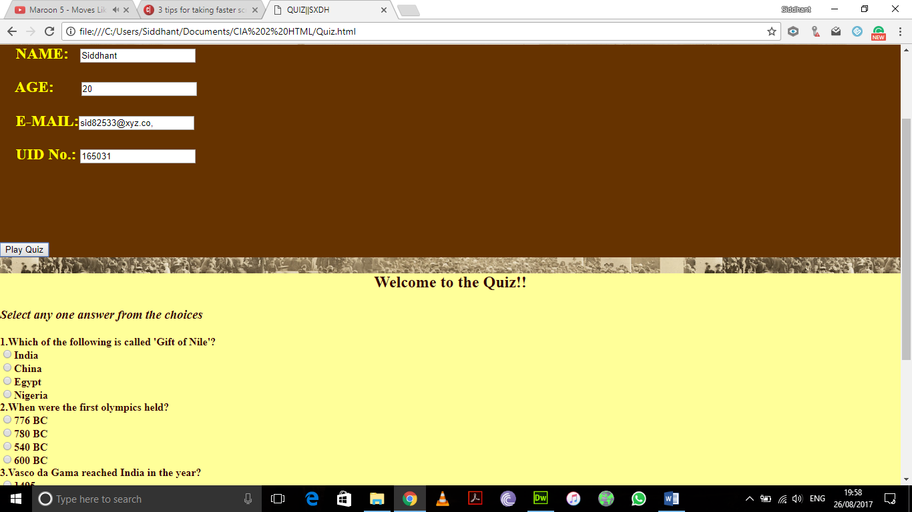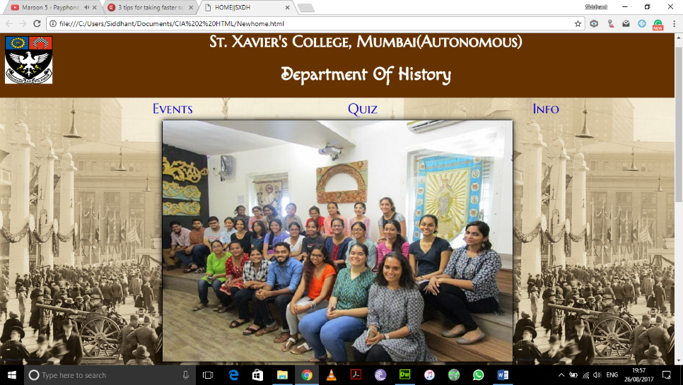**Snaps:**

**Software Used:**

We used Adobe Dreamweaver and Notepad++ for creating, designing and editing our webpages.

**Experience:**

This was an informative project. The world around us is becoming competitive and Web Designing and Development is certainly a strong area, keeping career in mind. What we achieved and learnt doing this project is merely a scratch on the surface of web language. There is a lot to learn in this subject and we hope to do so in the coming months. By doing this project we have learnt how to use jQuery and JavaScript in our website to make it more responsive and user friendly. By adding the vast amount of CSS, we learnt the various designing aspects that were not covered in our regular lecture times. There were a lot more improvements that could have been added to the webpages to make it even more responsive than it is now, but given the time bounds we could create what we believe was our best work.

**Bibliography:**

* <https://www.w3schools.com/> - W3 Schools
* [www.youtube.com](http://www.youtube.com) – YouTube video tutorials
* Classroom and Practical Lecture Notes
* We’ve also used various websites’ codes in order to understand how we would structure our webpages. These are reputed websites and not web templates available online.
* These websites include apple.com, malharfest.org, etc.